**Geography 150: Olympic College Soil lab**

**Tracy Harvey**

*Consult the soil survey materials (in links below) to respond to the following*

What is/are the primary soil types that are mapped in the area of Olympic College?

The primary soil types mapped around the area of Olympic College are Alderwood Gravelly Sandy Loam.

Give information for the following using soil descriptions and characterizations:

General topography (e.g., hill, slope, ….)

Gently sloping terrain and small hills.

Surface organic layer description:

A thin layer of decomposed organic matter.

Native vegetation:

Coniferous and deciduous trees and shrubs.

Available water capacity, if noted:

Ranges from moderate to high.

Plants that can be grown without amending the soil:

Various native ferns and other native trees like the Big leaf maple, Douglas fir and Western Hemlock.

Potential yields of crops per acre (if noted in description):

Not Noted.

Building potential of soil:

This soil is good for urban development if community sewage systems are built.

Map overview:

[https://www.kitsapgov.com/dcd/DCD%20GIS%20Maps/Soil\_Survey.pdf](https://www.kitsapgov.com/dcd/DCD GIS Maps/Soil_Survey.pdf)

Kitsap soil descriptions:

<https://www.nrcs.usda.gov/Internet/FSE_MANUSCRIPTS/washington/WA635/0/wa635_text.pdf>

USDS reference for additional soil properties\*:

<https://sdmdataaccess.nrcs.usda.gov/>

**Soil types:**

A major factor in the classification of soils is soil particle size. Soil particles are categorized into groups according to size:

Clay = less than 0.002 mm in diameter

Silt = 0.002-0.06 mm

Sand = 0.06-2.0 mm

Gravel = greater than 2.0 mm

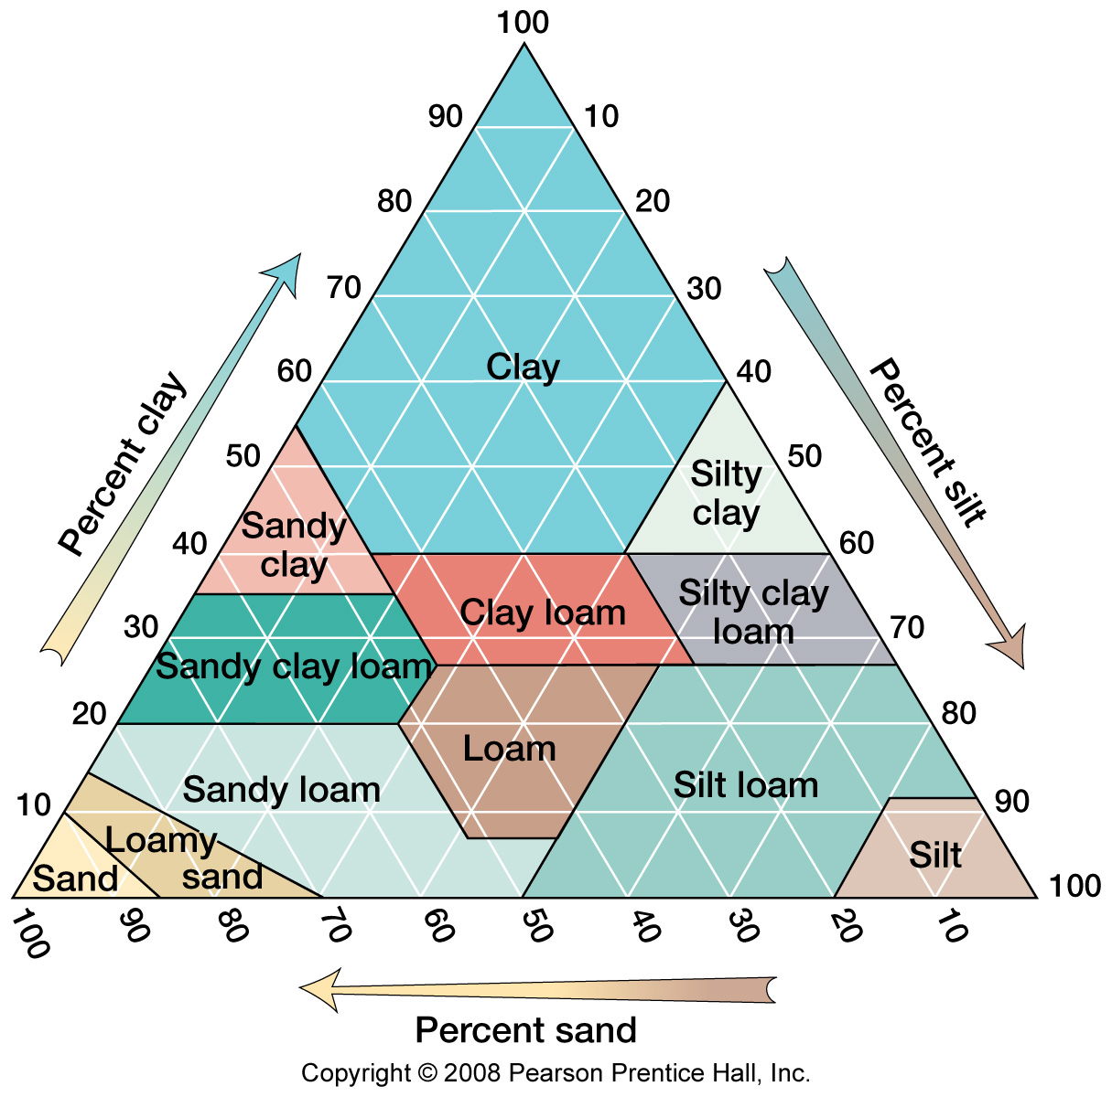

Depending on the amount of soil in these particle sizes, a given soil can be classified into the following categories:

***Sands*:** Soil that contains 85% to 90% or higher sand with no more than 10% clay or silt.

***Loamy sands***: Soil that contains between 70% to 85% sand with clay being 20% or less.

***Sandy loams***: Soil with 52% or more sand and 20% or less clay.

***Loam*:** Soil with 7% to 27% clay, 28% to 50% silt, and less than 50% sand.

***Silt loam***: Soil that contains 50% or more silt and 12% to 27% clay, or 50% to 80% silt and less than 12% clay.

***Clay loam***: Soil that contains 27% to 40% clay and 20% to 45% sand.

***Clay:*** Soil that contains 27% to 40% or more clay, and less than 45% sand and less than 40% silt.

**Identifying a soil**:

*Note: we normally use test tubes and stoppers in the lab. It is unlikely that most of us will have test tubes around the house. A cylindrical jar would work well, with a lid (ideal might be an olive jar or similar shape. Cylindrical bottles could work well also, with a wider lid being preferable. Anything with a tube shape that we can see through may work.*

1. Fill the test tube about half full with a soil sample.
2. Add water.
3. Put a stopper in the tube and shake to mix the soil and water.
4. Let it sit for 15 minutes while the soil (sediment) settles to the bottom.
5. Measure the amount of soil in each category, using a ruler and a magnifying glass. Record the following:

|  |  |  |  |  |
| --- | --- | --- | --- | --- |
| Particle size: | Depth of layer: (mm) | Fraction of total soil: mm/total mm | Percentage of total soil: | Other notes: |
| Clay and silt | 35 | 35/80 | 43.75 |  |
| Sand | 30 | 30/80 | 37.5 |  |
| Gravel | 15 | 15/80 | 18.75 |  |

1. Based on your analysis, what type of soil do you have?

I would say that I have clay but very close to clay loam

1. Color of water?

A muddy brown

1. Presence of floating organics:

There are some floating organics

1. Quantity and origin of organics?

There is not much as far as floating organics and it looks like the organics might have originated from grass roots or something similar.